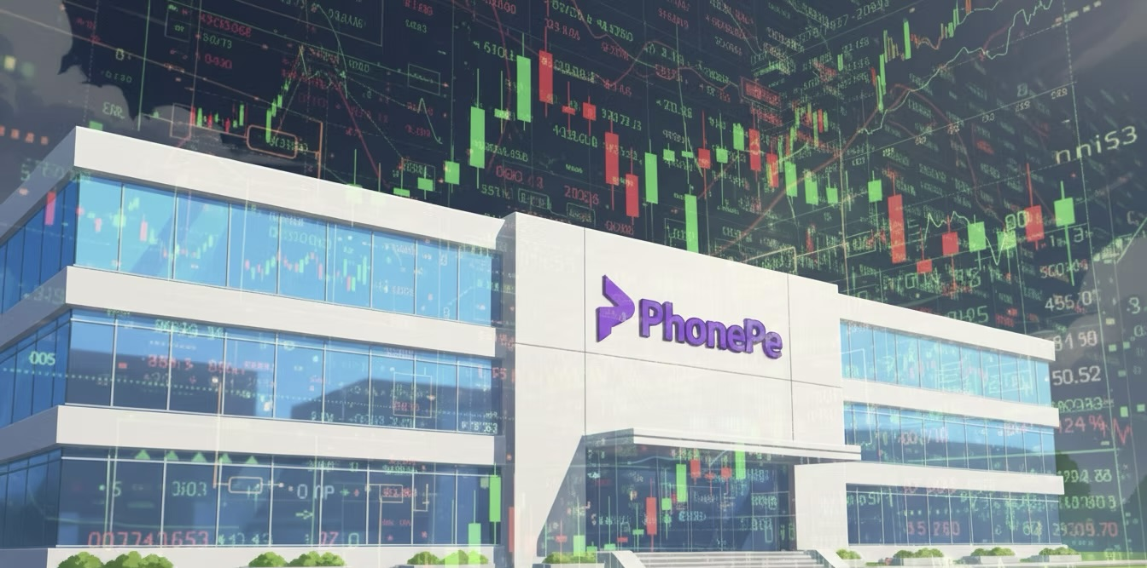

While the name may still seem outlandish to global investors, even whimsical to Indians, it has almost become synonymous with money movements. There are approximately 600 million registered users and a robust network that extends to small towns and dusty bazaars; nearly half of all transactions are processed through this powerful UPI payment trail. Last month, it handled over 8 billion transactions, a volume that would put many U.S. fintech associations to shame.

Walmart-backed PhonePe had quietly completed the entire process through a Confidential Draft Red Herring Prospectus; it was neither loud nor flashy, just the classic way of choosing the confidential route of pre-filing. By midday, the excitement had rippled beyond Dalal Street, catching the attention of global investors from Wall Street to Singapore.

The Emergence of a Payment Giant

PhonePe debuted in 2015 against the backdrop of India’s demonetization policy, which rocked the economy and thrust millions into digital transactions effectively overnight. While Paytm was the face of digital transactions in India, PhonePe quietly established its business, expanded its brand trust and pushed into an aggressive merchant acquisition plan. Today, the numbers are mind-numbing.
Over 8 billion transactions each month on India’s UPI system.
A 40 million merchant network.
Almost 45% of all UPI transactions in terms of market share.
It is more than just an app; in many ways, PhonePe is the rails of India’s cashless economy.

Walmart’s Billion-Dollar Bet

For Walmart, which had invested in Flipkart and acquired a majority stake in PhonePe, the IPO is more than an exit option. When Walmart bought Flipkart in 2018 for $16 billion, critics questioned if it had overpaid for an e-commerce player in an industry with notoriously low margins. But now, PhonePe—which Walmart aggressively spun out of Flipkart—has become the crown jewel of that investment.

With plans to IPO at a $15 billion valuation and raise $1.3–1.5 billion, Walmart has the opportunity to prove the naysayers wrong.

The Balancing Act: Growth versus Profitability

PhonePe faces a universal challenge that fintechs globally share: how to monetise payments profitably.

UPI transactions in India are effectively zero fee. The government has framed the system as a public utility, and consequently, companies such as PhonePe do not generate significant revenue for each swipe, scan, or transfer.
So the focus has been to cross-sell—
➢ Alternatives for small merchants.
➢ A form of insurance for individuals.
➢ Wealth management products for urban millennials.
➢ Even an app store (IndusOS) is billed as an alternative to the Google Play app store.

Yet, the numbers are beginning to show some movement:
➢ FY 2025 revenue increased 40% year over year to almost ₹2,000 crore.
➢ The net loss decreased to ₹1,720 crore compared to ₹1,996 crore the previous year.

Most importantly: positive cash flow of ₹1,202 crore—the first in PhonePe's history.

It is the sort of fiscal trajectory that investors and others on Wall Street enjoy: losses more minor, revenues higher, and a journey (though bumpy) towards sustainable profitability.

The Regulatory Landscape

Recently, PhonePe received approval from the Reserve Bank of India (RBI) to become a payment aggregator, which will give the company more control over its relationship with merchants. It also relocated its holding company from Singapore to India to gain favour with regulators and local investors ahead of its IPO.
Nonetheless, risks remain. Indian regulators have discussed the idea of imposing market share limits for UPI players to prevent any one company from becoming too dominant. If these limits were implemented, PhonePe’s dominant market position might become a liability.

The Competitive Landscape

The PhonePe saga would not be complete without its competitors.
Paytm, which was once the poster child of India's fintech boom, finally went public in 2021 in one of India's most anticipated IPOs. As expected, the stock dropped quickly and traded considerably below its issue price. Investors who got burned by that offering will be keeping a close eye on PhonePe.

Among its competitive set, Google Pay is the only real peer in terms of transaction volume. But because it has not yet been monetised sufficiently in India, it plays second fiddle to PhonePe's local agility.

Newer players, such as Amazon Pay, Cred, and BharatPe, nibble at the edge, but none yet are a genuine threat to PhonePe's underlying monopoly.

For PhonePe, the challenge is not simply avoiding competition but also convincing the broader market that it will not become "Paytm 2.0."

The Investor Inquiry: Is $15 Billion Excessive?

Markets are cyclical in nature. And while the IPO pipeline in India is red-hot, global markets are less forgiving. The rise in interest rates, geopolitical risk, and fluctuations in tech stocks have caused investors to be squeamish about large valuations.

PhonePe’s asking valuation—$15 billion—may be ambitious. Some bankers argue that it is justified, given the company's market position and cash flow turnaround. Other bankers say that it may face opposition if PhonePe does not demonstrate traction in monetising lending and insurance.

Conclusion

PhonePe’s IPO is not just another listing; it is a pivotal moment in India’s digital finance journey. With a nearly 50% share of the total UPI transactions, PhonePe is at the epicentre of India’s cashless economy. Walmart’s $3 billion bet on PhonePe is finally being realised in an IPO that will serve as both validation of Walmart's strategy and a test of global investors' appetite.

However, the road ahead is littered with the same fintech traps: very low margins on payments, constantly changing regulations, and the lingering stigma of Paytm’s IPO. What makes PhonePe unique is its ability to scale trust, turn free transactions into a funnel for profitable cross-sells, and be disciplined about generating cash flow—indicators that are still early but promising.

If investors think that India’s fintech story is still in the early innings, PhonePe has the potential to be the crown jewel of that story. Suppose global concerns over board valuations and regulatory challenges dominate. In that case, the dream of a $15 billion internet company may not seem so realistic, and being worth close to $15 billion would be a dream only.

Authored by Deepika Bhattad

